RECIPES

Pastel de Choclo
Ingredients
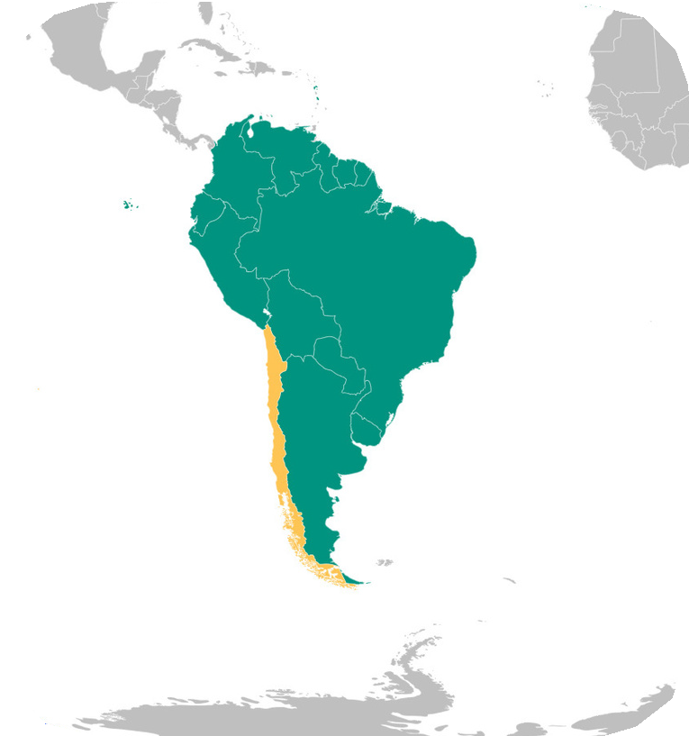
4 onions. 3 tbsp vegetable oil. 1.5 lb ground beef. 2 tsp cumin. 2 tsp salt. 1/2 tsp pep- per. 3 cups corn kernels (if using sweetcorn, lessen sugar) 1 cup whole milk. 1/4 cup butter. 1 tbsp sugar. 2 tbsp basil. 1/2 cup raisins. 1/3 cup black olives. 3 hard-boiled eggs. 1 cup roasted chicken (shredded).
Chile
Instructions:
- Sauté the onions in vegetable oil until soft/ translucent
- Add ground beef, cumin, 1 tsp salt and pepper and cook until brown. Drain excess
liquid.
- Combine corn kernels and 1/4 cup milk in a food processor. Blend till smooth.
- Melt butter in saucepan. Add corn mixture, 1 tsp salt and sugar.
- Add remaining milk and simmer over low heat till mixture thickens. Stir constantly. 6. Remove from heat and add chopped basil.
- Place cooked beef mixture in casserole dish
- Chop olives, raisins, and hardboiled egg roughly. Spread evenly over beef.
- Evenly spread shredded chicken, then top with the thickened corn mixture
- Bak​e 30-45 mins until dish bubbles and corn begins to brown. Serve hot.

Tapioca Pudding

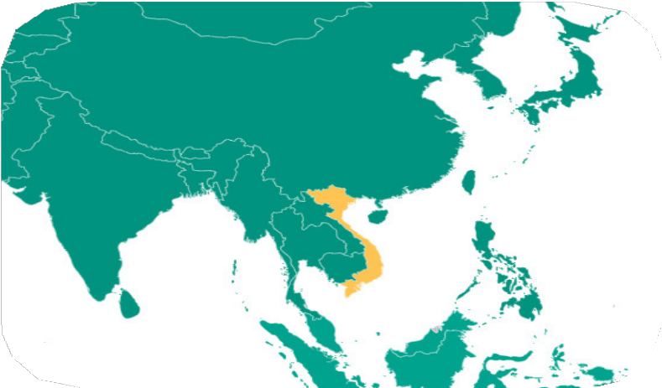
Ingredients:

Vietnam
2 2/3 c tapioca. 1 can coconut milk. 5.5 cups sugar. 1 tsp salt. 16 cups water.
Instructions:
- Bring water in a medium pot to a boil and add tapioca. Boil for 5 minutes on high.
- Reduce heat to medium and continue to cook for 90 mins.
- Add sugar and salt. Mix gently and cook till sugar is dissolved.
- Add coconut milk and gently mix.
- Let cool and serve cold.

Chakalaka

Ingredients
3 tbsp oil. 1 onion finely chopped. 2 green birds-eye chiles seeded and chopped. 2 crushed garlic cloves. 4 tbsp finely grated ginger. 2 tbsp mild curry powder. 1 finely chopped green, red and yellow bell pepper. 5 large carrots grated. 1 can chopped tomatoes. 2 tbsp tomato paste. 1 can baked beans. 2 sprigs fresh thyme leaves.salt and
pepper.

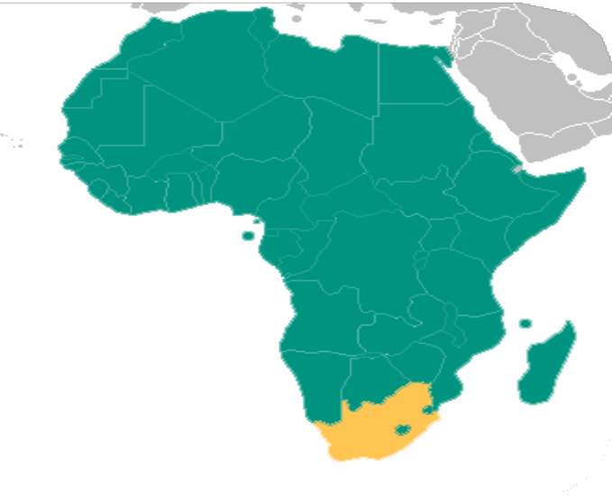
Instructions:

South Africa
  - In​ a large pan or pot, heat the oil and fry the chopped onions
  - Ad​d the chilies, garlic, curry powder, and half the ginger, reserving the other half for the end of the recipe.
  - On​ce that has combined, add the bell pepper and cook for 2 minutes until slightly softened.
  - Ad​d in the carrots and stir until well combined.
  - Fi​nally, add in tomatoes and tomato paste, then simmer until the mixture has slightly thickened, 5-10 minutes.
  - Re​move from heat, then add baked beans, thyme, and ginger. Season to taste with salt and pepper, and serve hot or cold.

Aloo Chaat

Ingredients:
3 large potatoes, cubed 1/2 inch. 3 tsp lemon juice. Salt to taste.
1 tbsp grated ginger. Oil to fry. 1 large, chopped onion. 1/2 tsp chaat masala. 1/2 tsp red chili powder. 1/4 tsp cumin powder. 2 green chilies chopped. 3tbsp fresh coriander leaves chopped.
Instructions:
- Add 1 tsp lemon juice and a pinch of salt to grated ginger and keep in refrigerator till use.
- Heat oil in pan till medium hot
- Add potato pieces. Deep fry till crisp and golden.
- Transfer potatoes in big bowl. Add remaining ingredients.
- Garnish with grated ginger mixture and serve immediately.

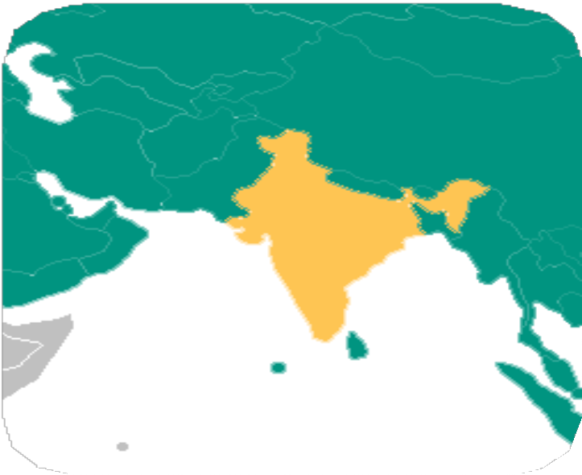
All of these recipes were submitted by IUPUI students, faculty, staff, or scholars
India

Scottish Shortbread
Ingredients:
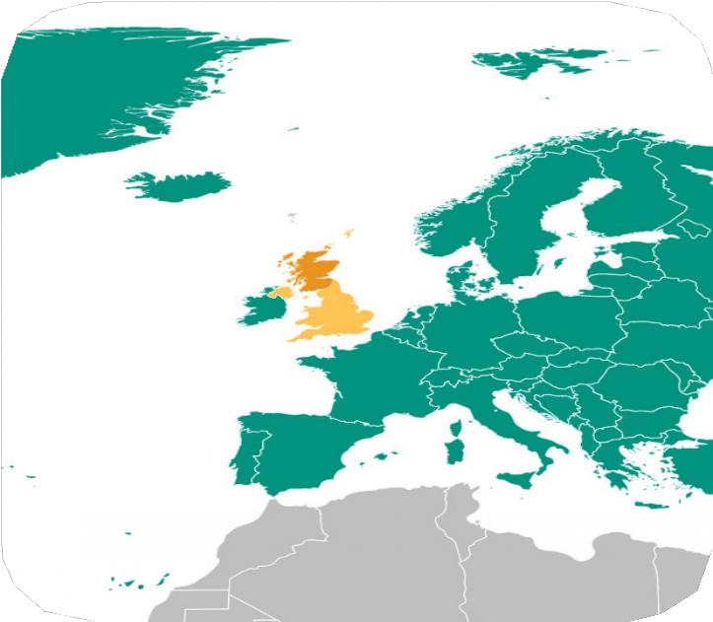
1 cup cold unsalted butter. Pinch of salt. 1/2 cup caster sugar (extra fine.) 2 cup all-purpose flour. 7 tbs cornstarch

Scotland
Instructions:
- Preheat oven to 325 F.
- Cream together the butter, salt, and sugar until fluffy and pale in color. (10 mins approx.)
- In separate bowl, mix flour and cornstarch.
- Using a sieve, add dry ingredients to wet and mix until combined. It should have crumbly texture.
- Tip the crumbly dough onto a cold and floured surface and knead lightly until it forms a loose dough.
- Grease a 13x9” pan with butter, press the dough evenly into pan and poke evenly across surface with fork.
- Bake 45 mins or till golden- brown.
- Cut sheet of biscuit into squares while still hot. Let cool before removing squares from pan.

Milk Tea

Ingredients:
1 cup water. 3 tbsp black tea leaves. 1 cup milk. Sugar to taste.

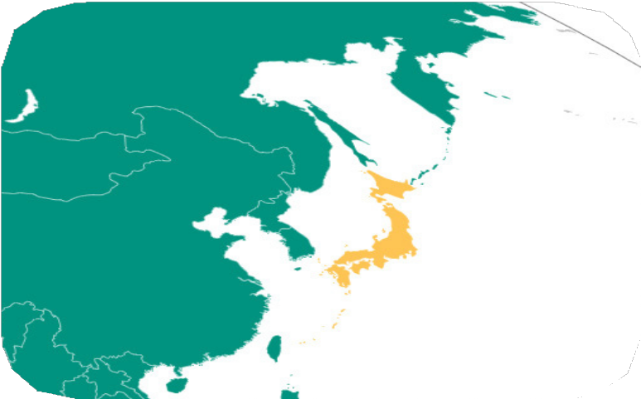
Instructions:
Japan
- Bring the water to a boil over medium high heat.
- Add the tea leaves, reduce heat and simmer for 1-2 mins.
- Add milk slowly and bringing to a gentle simmer, but not boiling.
- Remove from heat, pour through a strainer, and serve warm with sugar to taste.

All of these recipes were submitted by IUPUI students, faculty, staff, or scholars.

