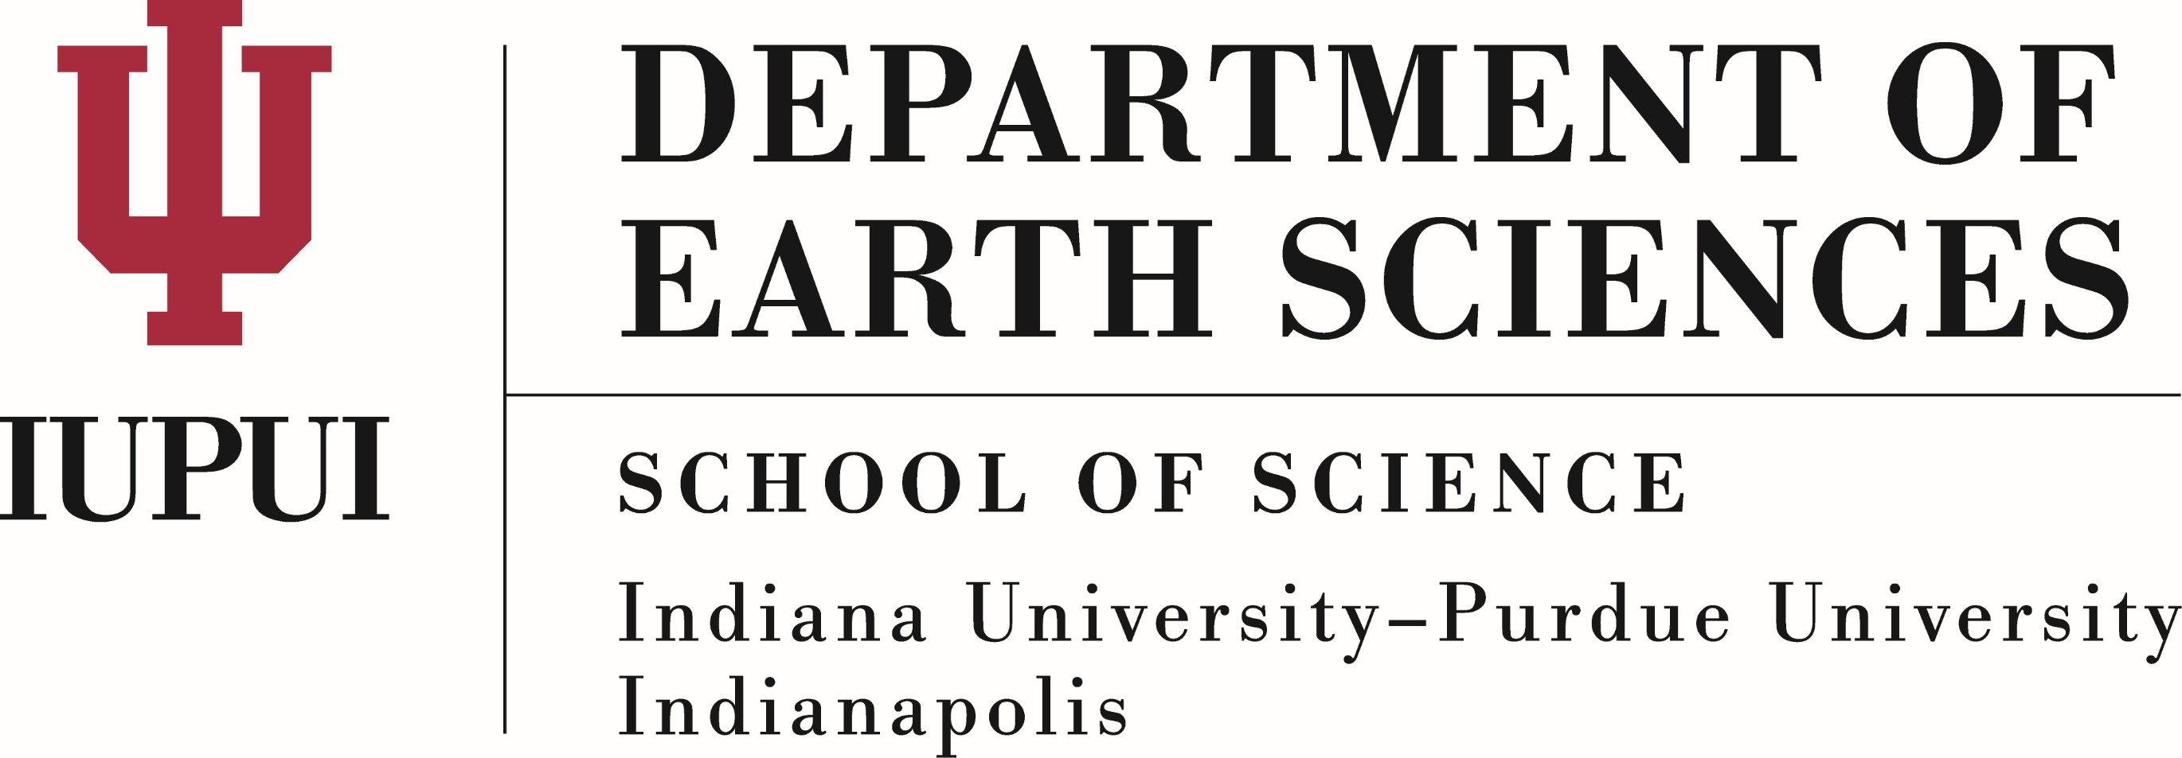

Opportunities for Reform in Myanmar’s Conflict Economy: Researching Options for Natural Resource Governance in Myanmar

A report submitted to Suzanne Yountchi, U.S. Embassy Myanmar June 13, 2017

IUPUI Department of Earth Sciences
Derek Gibson, Shelby Gills, Garrett Goff, Chase Howard, Theresa Hudson, Christa Phelps, Jennifer Laughlin, Leanne Lautzenhiser, Chris Mallery, Taylor Rupard, Ian Sampson, Thomas Utter, Courtney Wells; Professor Gabriel Filippelli

Overview
Several opportunities exist for Myanmar to strategically develop environmental protections, optimize resource utilization and recovery, and develop a more informed and skilled workforce in the area of environment and resource studies. We developed these opportunities in a set of presentations already delivered, based largely on approaches that other countries have used to protect resources and to maximize national benefits from these resources. Here, we summarize our main points from these presentations.

Resource identification and expertise training
Vast reserves of untapped extractive resources exist within the borders of Myanmar in the form of jade minerals, gemstones, oil, and natural gas. With the rebuilding of Myanmar’s governmental, financial, and environmental policies, significant potential exists for the efficient extraction of these resources in order to improve the economy of the country and, with that, the lives of the Burmese citizens. To ensure that the resources are extracted and used responsibly, a top priority should be to establish accurate quantified estimates of the remaining reserves of these resources within Myanmar’s borders. This can be accomplished by establishing a federal Geological Survey, tasked with mapping and extrapolating the extent of the currently known resources, as well as the quality and extraction economics of these resources. This will require training scientists, engineers, and environmental specialists at the university and indeed graduate student levels in the broad geosciences, and retaining these trained individuals in-country to further federal expertise building and to provide non-governmental entities with a pool of qualified individuals. This has multiple benefits: the potential economic gains associated with

accurate and updated resource maps can offset initial expenditures required for the development of a well-trained team of federal geoscientists, and building an expert workforce in-country significantly enhances the capacity for entrepreneurship and the potential for in-sourcing of expertise in developing sustainable commercial enterprises revolving around resources.

Myanmar employs in practice a very short economic valuation chain to resources that are identified and extracted. Many of these resources, including stone, metal, and hydrocarbons, are exported with very little processing, and imported back again for use after refining/finishing. It is important to develop training and capacity to promote effective beneficiation—i.e., a improving the economic value of a raw resource by processing, refining, and/or finishing. This process also can be integrated into a full value philosophy whereby the leftover material is otherwise purposed or recycled as a valuable commodity in and of itself. The two hurdles to this resource reform are developing the infrastructure and capacity for beneficiation and developing the trained local workforce to perform this process. Both hurdles can be overcome with a combination of national investments and strategic international partnerships with an aim to capture greater economic benefit from resource extraction, while also valuing education and workforce development, and environmental stewardship, as economic benefits for current and future generations of Burmese.

Environmental, economic, and human health issues around resource extraction
The major natural resources of Myanmar (Jade, Teak wood, and Natural gas) represent great national assets, but have not been managed sustainably, in such a way as to balance short-term profit, environmental health, and human health. Jade represents a large percentage of Myanmar’s GDP, but much of the jade is exported with little or no net value improvement from processing or finishing. Furthermore, there are issues with occupational health and safety of mining operations as well as a lack of transparency in the jade industry. Laos might be a good development model, as since 2003 they have invested heavily in developing maps of resource and in working collaboratively with a host on international partners to develop a robust and more sustainable mining sector. Teak wood is valued worldwide and Myanmar has 50% of natural teak, and thus it is critical that Myanmar should profit from their resource (aka “Burmese Teak”) while keeping their ecosystem services intact. Several initiatives could assist in limiting resource depletion and maximizing return, including propagating teak wood for profit on plantations, protecting natural teak forests by encouraging endangered species preservation, developing an ecotourism industry, and enforcing laws to stop illegal logging. Natural gas is a valuable resource, but concerns exist about current models for well field development and export. There should be an examination of best practices utilized in other countries for well development to reduce local pollution, as well as better oversight into environmental degradation in pipeline construction and maintenance to reduce health impacts on affected populations.

Additionally, the regulations around resource development and extraction need to be carefully assessed. With the Environmental Conservation Law of 2012, a solid roadmap exists upon which to ensure that all entities (i.e., companies, projects, citizens) are treated equitably when it comes to the rules and regulations of this law. The key is to strengthen the reporting, surveillance, and enforcement continuum, both for domestic projects and international partnerships. This will have a double benefit not just for environmental protection and resource stewardship but also for enhancing international economic partnerships with international companies that prioritize sound and transparent practices and accountability.

Conclusions
An educated citizen body is the common denominator for any nation, as many of its focuses will surround outlets of revenue generation and the generally more profitable routes are those that require specialized skills. A constitution of equal rights and collective justice are imperative for the individual and the progress and protection of industry/trade. Remediation is costly to industry and commerce and the omission of environmental considerations into public policy is dangerous to public health and safety.

